**What Will Happen If Computers Aren't Recycled?**

The Earth is the world's largest recycler. It recycles and reuses practically all dead and waste components, such as dead plants. Earth utilises the stuff already existing in the soil to feed animals and nourish plants. And yet, when someone wonders what will happen if we don't recycle, we don't even blink.

Plastic has spread all over the place since its invention. It's overrunning landfills because it doesn't decompose, and it's clogging up the oceans with waste that harms and even kills marine life. Discarded IT equipment is one of the most significant contributions to landfills.

Although concepts such as computer recycling and secure IT disposal are becoming more popular, many people still overlook their significance. The environmental dangers posed by a lack of recycling are significant.

We will try to throw some light on the relevance of computer and IT recycling in this article. Furthermore, we will discuss the hazards that our planet will face if we stop recycling for good.

**What Happens If You Don't Recycle?**

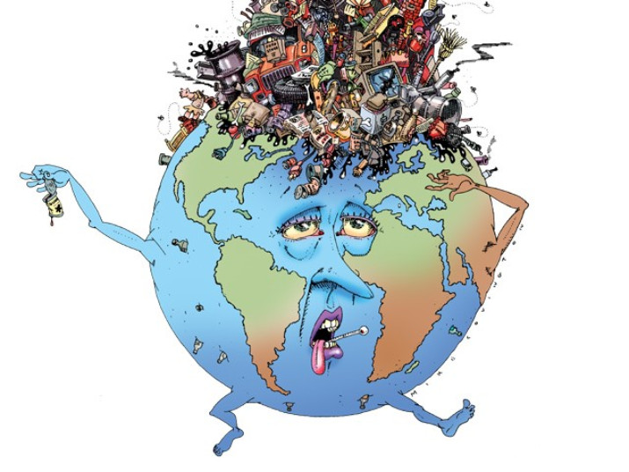

We've been emphasising the necessity of computer recycling for so long that we've forgotten to consider the consequences of not recycling. Perhaps there will be no need to lecture about secure IT disposals if we correctly discover the solution to this question.

Let's have a look at what happens if we don't recycle.

If people refuse to recycle in any form, the following will occur:

* Piles of Garbage
* Overflow of landfills
* Increase in pollution
* Expansion of greenhouse gases
* Reduction of natural resources

Now let us explore them one by one

**Piles of Garbage**

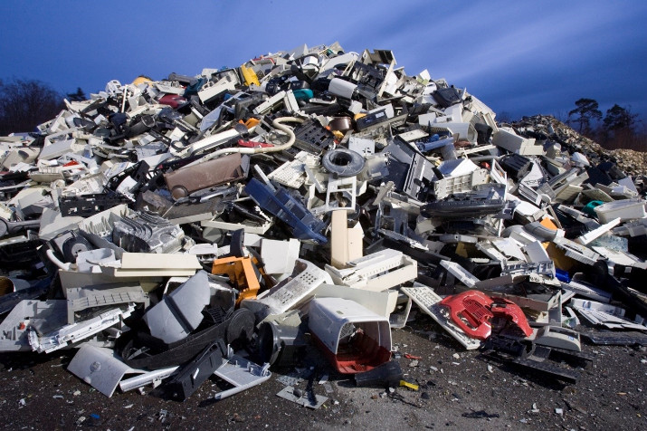

Every year, the Environmental Agency reports the quantity of e-waste created and disposed of in landfills. This figure continues to rise year after year. In the first quarter of 2018, around 122 thousand metric tonnes of WEEE were collected, according to Statista. These garbage piles are growing as a result of people's irresponsibility and lack of information about computer recycling.

1. waste does not end up in landfills because it is recycled 100 percent. Some of it is taken to recycling facilities and put to useful use. As a result, if we completely stop recycling, all discarded IT equipment will wind up in the trash. As a result, there will be massive piles of waste.

**Overflow of Landfills**

Even though landfills were built to handle e-waste, if we continue to fill them without recycling anything, they will fill up far sooner than intended. As a result of the enormous amount of waste, foul odours may develop in the surrounding area. Furthermore, IT equipment emits hazardous elements that might degrade the environment. As a result, we emphasise the importance of secure IT disposal by everyone who cares about the environment. With small recycling efforts, keeping landfills under control becomes considerably easier.

**Increase in pollution**

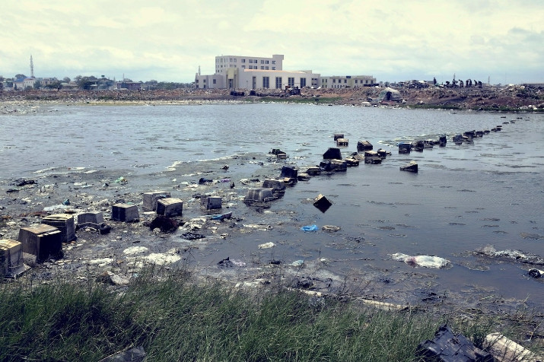

Because we don't take computer recycling seriously, pollution is wreaking havoc on our globe every day. Furthermore, this pollution is not of a single type, but rather a variety of types. Land, air, and water contamination are the three basic types of pollution. All three types of contamination are caused by improper IT equipment recycling disposal. When e-waste sits in landfills for a long time, hazardous elements can easily enter the environment. Furthermore, landfills are typically located near a water source, allowing toxic pollutants to seep into the water.

**Expansion of Green House Gases**

Are you still concerned about what will happen if we do not recycle? Continue reading!

Different changes in the atmosphere have occurred on our planet, and they have all been a part of its evolution. However, things are changing now as a result of increased fossil fuel consumption and a lack of recycling. The human population is now the leading source of ozone-depleting gases. These greenhouse gases, like methane and carbon dioxide, enter the atmosphere and make it impure. Recycling can have a great impact on the production of greenhouse gases.

**Reduction of Natural Resources**

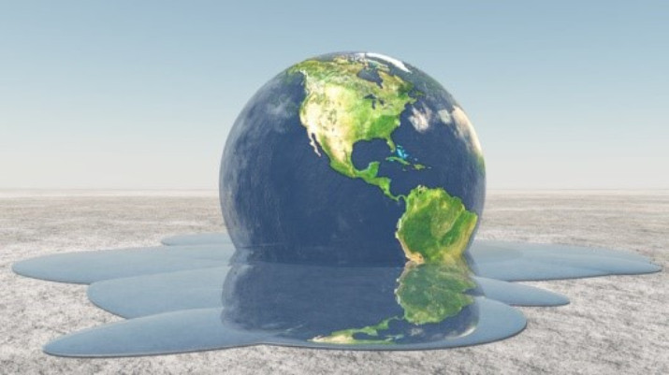

While the planet is constantly growing, its natural resources are continually vanishing. The majority of the materials used to design a computer end up in a landfill. This doesn't have the to be. Computer recycling is an option to reuse and save the materials used to make older computers. A report shows that recycling efforts in 2013 prevented 87.2 million tonnes worth of waste from ending up in landfills.

Let's see, what materials can enter our atmosphere if we don’t choose for IT disposal?

**Effects of E-Waste**

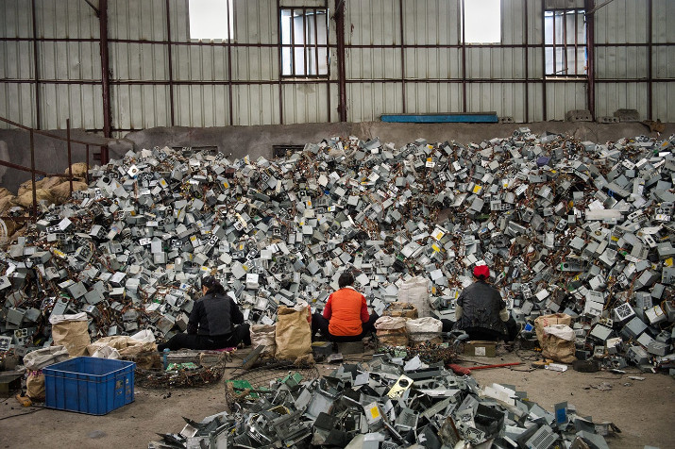

Each year, we destroy between 40 and 50 million tonnes of electronic gadgets. This number is expected to increase significantly over the next few years. This is due to the increasing rate at which newer IT gear is being purchased. Buyers need to be more careful about recycling their old equipment.

Most IT equipment is made of valuable metals. When we dump them in landfills, we are throwing away precious elements. We can both save resources and reduce environmental pollution by processing them and recycling them. The valuable metals include lead, mercury and cadmium as well as PVC, arsenic, and cadmium. If not treated properly, they can be dangerous metals.

**Lead**

Lead is often found in the glass used for circuit boards and computer screens. Lead can affect the central sensory system, reproductive system, and kidneys. It is easy to find large amounts of lead in computers. Therefore, it is important that you dispose of it legally.

**Mercury**

Mercury can be found in batteries, printed circuit boards and LCD/TFT screen. Mercury can also affect our nervous system, just like lead. It can also cause damage to our brains, kidneys, and lungs. Hypertension can also be caused by mercury. Although it is not present in high levels in PCs, mercury can still pose a threat to our health.

**Cadmium**

Cadmium is found in printed circuit boards, CRT screens and laptop batteries. Cadmium can cause kidney disease and affect the lungs. If it isn't discarded properly, it can react to air and cause breathing problems.

**PVC**

You can find polyvinyl chloride in nearly all IT equipment. It can be found in almost every part of the computer, including plastic packaging, drives and screens, wiring, and so on. It can cause permanent liver damage, nerve damage, skin irritation, and birth defects.

**Arsenic**

Arsenic is used in printed circuit sheets and transistors. If arsenic is not taken care of, it can cause serious health problems. It can cause irregular heartbeats, damage blood vessels and increase blood cell production.

**For Assistance, Please Call Us**

### Secure IT disposals and computer recycling are effective ways to protect the environment from the toxins in the air. As the world is becoming more populous, we recommend recycling. This causes a decline in natural resources, which has a significant impact on the environment. E-waste can be recycled for many purposes. You can recycle your laptop or computer parts legally by choosing an efficient agency.

[Recycle Pro](https://www.recyclepro.co.uk/) has extensive experience in recycling IT gear. They are also experts in secure IT disposal. Their IT recycling UK team will assess the potential value of your organization's large-scale recycling.